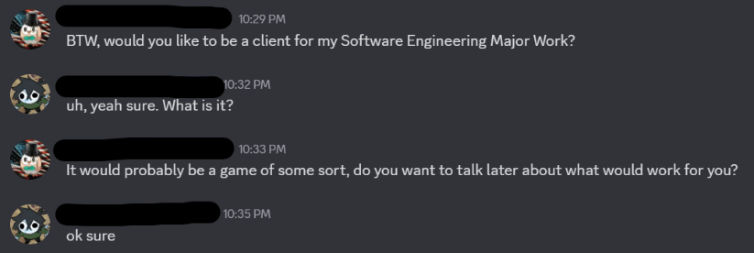Meeting minutes

Meeting 1: 6 January 2025

The client was asked if they were interested in being a client the day before, and they agreed.

My client discussed how they would like a game they can play with friends that is similar in nature to Hypixel Skyblock and Gregtech. However, they noted that these games are highly addictive and cause them to spend a large amount of time not on schoolwork. I agreed, and suggested that maybe an idle game would be a better fit, especially if they were going into Y11 soon, but they still wanted some level of active gameplay.

I threw around a few ideas and we came up with several ideas together, which related to one specific area of these games, noting the time restriction that I had during this first term due to extracurricular commitments and other subjects. This resulted in the suggestion of a game similar to the gameplay loop of Hypixel Skyblock’s Garden zone, an external island where players can create custom farms for a variety of crops and farm to collect resources, make in-game money, and compete against each other in farming competitions to earn prizes. This was a simpler idea than a game similar to the Dwarven Mines, an area for mining, which would have quickly resulted in scope creep.

We agreed on this, and he provided me with some more requirements, such as wanting to be able to play it on lower end machines as several of his friends have old Windows computers are old school ones. He also expressed interest in continuing the project later on, as he enjoys programming and game development as well, so I agreed that I would try to make the game as modular and easy to understand as possible to allow for future development. We both also agreed that it was a no-brainer that the game should be able to be saved for persistent gameplay.

Meeting 2: 2nd February 2025

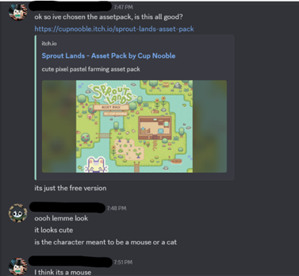This second client meeting was conducted primarily via text message, which allowed for a more focused exchange of information regarding the project.

I shared a detailed outline of what the final product was expected to look and sound like, including:

* The art direction of the game, which featured a 2D, block-based sprite pack and tilemap terrain.
* The audio atmosphere, including background music inspired by other idle games and animal sound effects.
* The planned technical features, such as tile interaction, time progression, semi-idle gameplay mechanics, inventory handling, and saving/loading functionality.

The client responded positively to the visual style, particularly appreciating the pixel-based terrain and retro-inspired aesthetic, which he felt was approachable and matched his vision for a study-friendly, distraction-free game. He agreed that the 2D nature of the game would also help it run efficiently on his friend’s school laptops.

We also discussed the save system, including my intention to use Godot’s functionality to serialise game state into .res files. I explained my plan to apply an XOR cipher for obfuscation, which would help deter casual tampering or unfair editing of save files. The client was enthusiastic about this idea, noting that he liked the concept of “soft security” for game progression fairness, especially if others would also be playing and comparing progress. I also shared a draft of the functional and non-functional requirements, outlining features such as tool switching, idle farming mechanics, and system performance expectations. The client approved all proposed requirements and agreed that they aligned with his goals for the project. We discussed the inclusion of a user instruction system or tutorial. The client clarified that a fully integrated instruction manual or tutorial screen would not be necessary, but instead, he stated that a post-development explanation from me on how the game worked would be sufficient, as the target audience (his peers) would be familiar with basic game controls and expected interactions.

Meeting 3: 9th May 2025

This was the third meeting with the client during which I showed him the finished state of the game.

I sent these over several videos, which presented the finished version of the game by showcasing a variety of the features, such as:

* The player movement and interaction with environmental objects (e.g. trees, rocks, chests).
* Tilling and planting mechanics, allowing players to interact with the grass using the hoe and interact with plants using the watering can.
* Crop growth logic, including time-based progression and harvesting. This was demonstrated using the cheetah mode in the recording.
* Animal feeding and reward system, showcasing the reward drops tied to the visible inventory.
* Save/load functionality, demonstrating persistence of inventory, object states, and the settings.
* Customisable settings, such as audio volume and day/night toggling.
* Visual UI design, including tool indicators, time-of-day displays, and interaction prompts.

My client was happy with the final product; they specifically liked the smooth and intuitive graphical interface, which included the visual clarity of the icons and the consistent pixel art style that I chose. When reviewing the save system, he appreciated that the game could be closed and resumed at any time without losing progress and was a fan of the XOR obfuscation technique that I implemented as a fair method to deter tampering, and confirmed that this addressed his concern about players editing their progress externally.

Finally, we reviewed the overall performance of the game on a low-end school laptop, with me videoing it running on my sister’s laptop. The game ran well for the system that it was running on. Finally, my client confirmed that the final product had met his expectations and stated that he was happy to use it as a casual game with his friends.